Regular Meetings are the 3rd Thursday of each month unless otherwise posted.  BMCCF NOTE:  Next Meeting – FEB 21ST  at Temptations  Dining @6:00pm  Meeting@ 7:00pm | BMCCF | The Cape Fear British Motor  Club Welcomes all Marquees,  Models and Motoring  Enthusiasts  For additions or submissions to  the letter contact the editor:  Charlie Schaefer or  BMCCF@ec.rr.com  Visit the website:  www.BMCCF.org
Volume 15 No.1 THE HUB January 2013
The Official Monthly Publication of the British Motor Club of the Cape Fear

BMCCF

Since BMCCF had their annual
Holiday Party
there will be no minutes this month
BMCCF CHILI, CHOWDER & DESSERT COOK-OFF!
Saturday, February 16, 2013
THIS IS AN RSVP EVENT BY: FRIDAY, FEB 15, 2013 TO: fosterhousejj@bellsouth.net

The annual BMCCF Chili, Chowder & Dessert Cook-off at Seapath Yacht Club, Seapath Marina , 328 Causeway Drive
Wrightsville Beach, NC
CHILI & Chowder tasting begins at 6:30 PM SHARP!! - YOU MAY ARRIVE FOR SET-UP ANY TIME AFTER 5:30
Bring your concoction of Chili, Chowder or Dessert for "voting" by all BMCCF members present.
Don't forget to bring your favorite alcoholic beverages if preferred!! Any and all beverages are OK. The club will provide soda, bowls, eating utensils, etc.
A prize will be awarded for the "Best Chili, Chowder and Dessert".
John and Joanne Foster will be hosting the event.
Please RSVP by Friday 2-15-13, call 910.270.7050 or email fosterhousejj@bellsouth.net

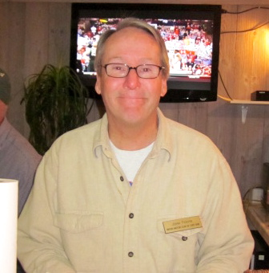
Look for the BMCCF Banner
in the parking lot!
Holiday Party Memories
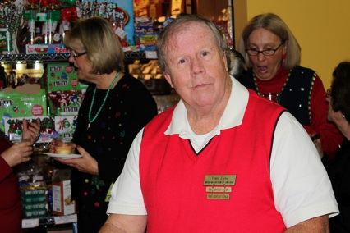
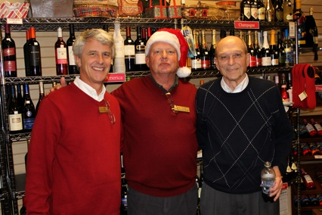
Photos by Pete & Karen Burr

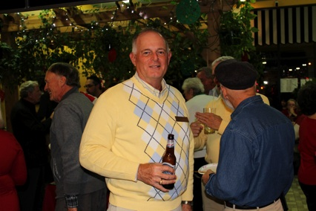
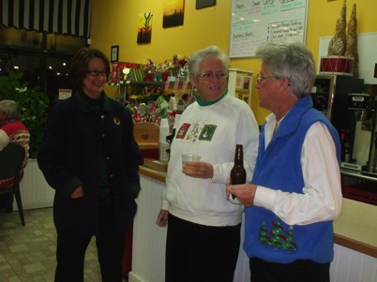
Brown bottles help our posture

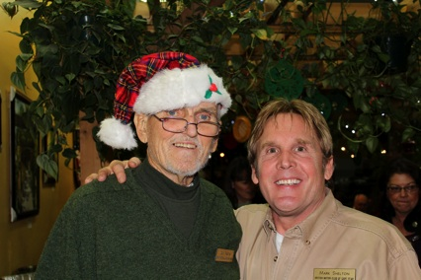
Smile you’re on BMCCF hidden camera

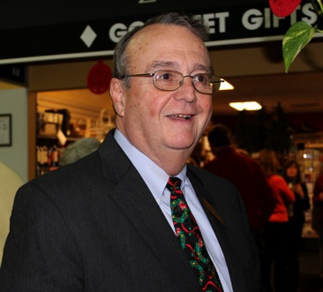
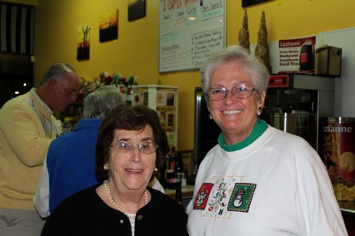
Good Friendships last a lifetime

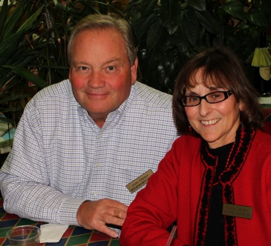
We are one Handsome Club.

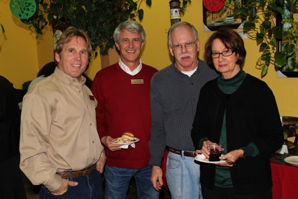

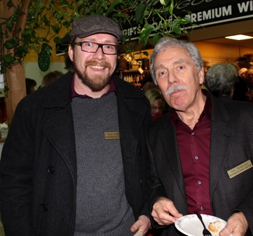

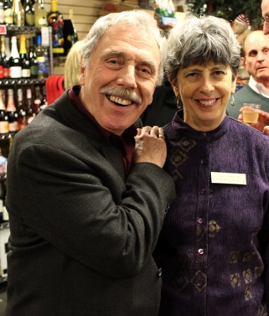
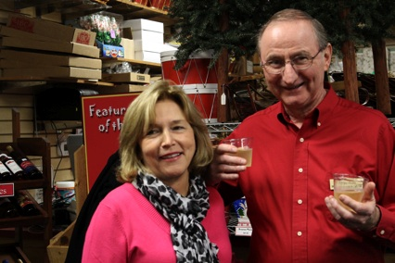
Man’s two favorite passions
Beautiful women & cocktails

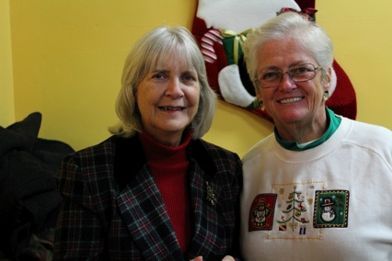
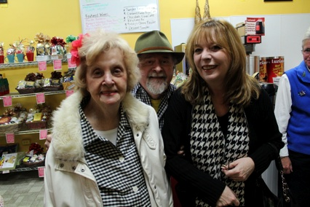

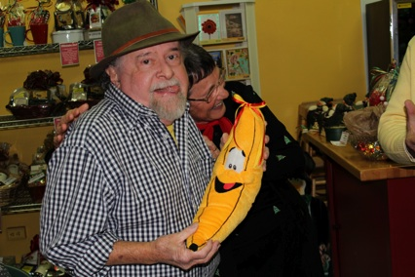
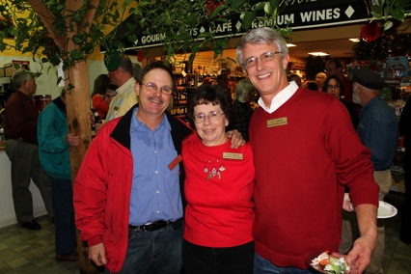

Coventry's Motor Industry
sent to us by: Eric Robinson
Attached is a piece taken from a magazine about my home county, Warwickshire, which talks about the car industry in my home town of Coventry.

From Warwickshire Life
For enjoying life in Warwickshire

Stephen Laing, curator of the British Motor Industry Heritage Trust,
takes us on a tour of the county's motoring history.

The British motor industry was born in Coventry and the area is still at the heart of the nation's motor industry. The great names in car-making - Jaguar, Rover, Triumph, Riley, Healey, Armstrong Siddeley, Daimler, Lea-Francis, Morris, Sunbeam, Talbot and more - all come from here.

On the face of it Coventry and neighbouring rural Warwickshire seem an unlikely setting for one of Britain's most successful industries. At the centre of the country we are far away from the coastal ports and areas of established heavy engineering as they were.
During the 1800s Coventry was a flourishing centre in watchmaking and, in turn, the sewing machine industry. As the 19th century drew to a close the latest invention in personal transport, the cycle, came along and Coventry's skilled workforce found itself suitably positioned to take on its development. Soon the city became a world leader in the cycle industry, many thousands of its residents employed in cycle production.
The first car
Although Germany was the birthplace of the world's first motor car, inventiveness quickly crossed the Channel and, in Coventry, motorising the cycle was a natural progression. With plenty of technical skill in place, the fledgling motor industry just needed business acumen. That came in the form of one Harry Lawson, a flamboyant entrepreneur who had made his fortune in the city's cycle industry. He had what might be called a creative approach to encouraging investment in the several companies he formed with the prospect of making motor cars!
Lawson acquired a factory from the Coventry Cotton Spinning and Weaving Company and installed his new car firms. An imposing four storey building, close to what is now the canal basin, it took the grand title 'The Motor Mills'. In 1896, the first Coventry Daimler car emerged - Britain's motor industry was born.

Riley
William Riley came from a successful weaving family and in years to come the Riley name become synonymous with successful sports and racing cars. Riley's new factory was established in the north of the city, at Durbar Avenue in Foleshill. Fortunes changed as the Second World War approached; the factory had become outdated and the company had to be rescued by William Morris. Although production moved away from the Midlands, the Riley name and its motto (as old as the industry, as modern as the hour) survived until 1969.

Rover
Morris himself focused car manufacture in his native Oxford. He had interests in Coventry, however, having acquired engine supplier Hotchkiss and established engine factories in Stoke and Courthouse Green. Not far away, the Rover company's Helen Street factory stood, producing the well-made, middle market sports saloons and tourers. Rover had been established by J. K. Starley and his business partner William Sutton. Originally one of Coventry's leading cycles makers, Rover had one of the largest factories in Coventry - the Meteor Works right in the heart of the city, on the site where the Indoor Market now stands. Like Riley, Rover's fortunes would change with the War but more of that later.

Armstrong Siddeley
At the opposite corner of the city centre, in area known as Parkside and now home to Coventry's
University, another area of motor trade grew up. The most successful was Armstrong Siddeley -the result of the amalgamation of motoring pioneer, John Davenport Siddeley's company and engineering giant Armstrong Whitworth. With models such as Typhoon and Hurricane, the car evoked Armstrong's aircraft origins. Siddeley himself was to become Lord Kenilworth and responsible for leaving Kenilworth Castle to the residents of the town. Humber and Hillman
A little to the south of the city, Humber established its motor operation. Another successful cycle
company its light car, the Humberette, made in the early 1900s was probably Britain's first mass-
produced car. In 1907, Hillman would become Humber's next door neighbour. William Hillman,
another cycling magnate, owned a large house, Abingdon House in Aldermoor Lane. The grounds were the natural place for a car factory. In time, the companies became not only geographically connected but merged as businesses in 1928. Both were part of the Rootes empire owned by two brothers who had been car salesmen. Rootes would also eventually swallow another Coventry firm, Singer and the Black Country manufacturer Sunbeam.

Rootes Group – Humber, Hillman, Singer, Sunbeam, Talbot
International conflict brought a rash of building work. The new 'shadow' factories, mirroring the work of established military hardware builders, were erected so the motor industry could build planes, tanks and munitions for the war effort. Rootes not only added to its Humber Road factory but a new facility was built a few miles away at Ryton. After the war this became the main focus of its production - who can forget model names like Snipe, Minx, Alpine, Tiger and Gazelle that sprang from this factory?

Peugeot Talbot
By the late 60s, prospects were not so rosy. US giant Chrysler took the reins and an old name was revived - Talbot. After an inauspicious decade of ownership, Chrysler sold to Peugeot and Coventry became the home of the French manufacturer's smaller models for nearly three decades. .

Land Rover
Wartime would also alter the course of Rover's history. Its shadow factory on the edge of Warwickshire at Solihull would become its main home in the late 40s. The Coventry factories had been heavily bombed and so manufacture moved wholesale to Solihull in just a few years. Perhaps its most famous product was the 'go-anywhere' Land Rover, originally perceived as post-war stop gap model. Sixty years on, it is still Solihull's most famous product but we should not forget the thousands of stately Rover cars that were also built, the models that whisked Prime Minsters to Number 10.

Triumph
To the west another of the early car makers, Standard, established its new factory at Canley in 1916 on an area of farmland, its city centre site being too small. Its headquarters building, Ivy Cottage, was a landmark on the A45 Fletchampstead Highway. Perhaps a less well-known make, Standard rescued ailing Triumph cars - by now separate from the motorcycle business - in 1945 and by the 1960s the former name had been dropped. Triumph, was well known for its range of sport cars, rivals to MG, including Bergerac's favourite drive, the Roadster. Rationalisation within British Leyland and Rover Group led to the factory's final closure in the 1990s, the site now occupied by a retail and industry park.

Alvis and the London Taxi
Also in this part of town were two very specialised concerns that both began in 1919, on the Holyhead Road. One was Alvis, a sports car manufacturer, whose red triangle logo was a familiar sign on the road to Birmingham. Alvis was the first company to mass produce a front-wheel-drive car, although that was almost its undoing. After the war it diversified into making armoured vehicles, the sports car business eventually becoming another casualty of British Leyland. The other manufacturer was Carbodies, one of several coachbuilding firms that emerged to service the fast growing car industry. It was after the war that it made a real mark, following a tie up with Austin to make a new taxi. The later FX4 model, introduced in 1959, set the iconic shape for London's black cab. Perhaps one of Coventry's best kept secrets, modern taxis still emerge from the same factory, the company now called London Taxis International, the last remaining volume motor car producer in the city.

Jaguar
A few miles further outside the city is Jaguar's Browns Lane plant. William Lyons had arrived in
Coventry in the 1920s but moved to a new factory in the post-War era. It was from Browns Lane that Jaguar gave birth to the legendary C-type and D-type racing cars, as well as the sensational E-type roadster. Lyons added the nearby Daimler company and its Radford works to his portfolio in 1960. Manufacturing of cars at Browns Lane ceased a few years ago - the majority moving to Castle Bromwich, once on the very western fringes of Warwickshire and home to the Spitfire - but the plant remains the home of Jaguar's highly skilled wood and veneer making centre.

Car parts in Leamington
Moving away from Coventry, Leamington also has a rich motoring heritage. Although there were two very short-lived motor car producers, Crowden and Invicta, before the First World War, Leamington became known for a thriving component industry. The biggest was Automotive Products, in the Tachbrook area of the town. Beginning with the Lockheed brake company and Bork and Beck clutches, AP was a major employer and even the local football club, once the factory team, acquired the nickname 'The Brakes'. In the centre of the town, Flavels foundry, which made parts for stoves and ovens, was acquired by Ford in the late 1930s for its work for the War effort and later producing small castings, such as brake discs. Until 2007 the factory clock and thermometer were a familiar sight to drivers entering the town from the South. Across Leamington, Ricardo's engineering research facility is a longstanding example of UK specialism in automotive design and technology.

Healey
In adjacent Warwick, one name dominates. Donald Healey moved from Triumph to set up his own business in 1945. Producing sports cars he set up factory in an old aircraft hangar in The Cape. A deal with the British Motor Corporation led to the advent of the famous Austin Healey cars - first the 100, then the 3000 and the endearing small car, the 'frog-eye' Sprite. Although they carried the Healey name, the cars were made at BMC's factories in Birmingham and Abingdon.

And today . . .
A drive further south into rural Warwickshire reveals one of the fastest expanding areas of automotive activities. British Leyland had taken on the site of the former airbase at Gaydon, once home to the V- bombers, as its test track in 1978. Today, the much developed site is the focus of Land Rover and Jaguar's research and development. Next door, Aston Martin builds its exotic sports cars, evoking the spirit of Britain's best known secret service agent. And a little further down the road, a visit to the Heritage Motor Centre will help you appreciate how important the region is to the motor industry and remind you of some of the great British motor cars that were made in Coventry and Warwickshire, an area home to more than 100 car companies and employers of thousands of people.
www.heritage-motor-centre.co.u

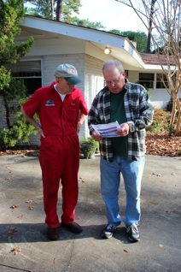
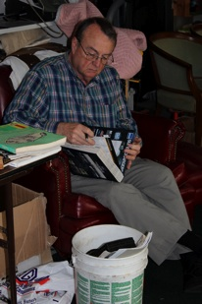
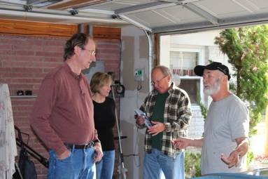
WORK PARTYATTACKIING SUSAN ROBERSON’S HEALEY
Rotten Frame needs TLC and then some...
John Moore & Mickey Finn to the rescue.

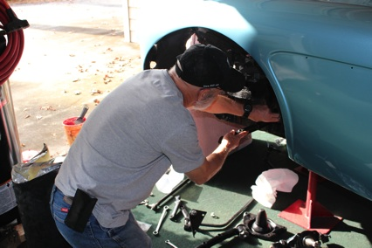
Rear end nearing completion - brakes, lines, all of it

Many hours getting this baby right.
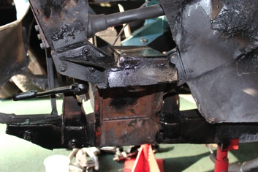

.

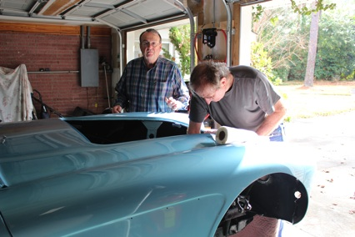
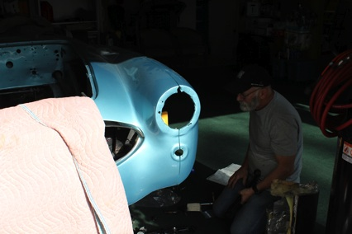
Many THANKS to our BMCCF Boys for putting Susan’s 1960 Healey back to her glory days - progress in motion.
She deserves it.... they both do
About the Pinehurst Concours d’Elegance
For more than 100 years, Pinehurst has crowned champions in some of the most prestigious golf events in the world. Now a new champion will be named on the storied links, this time for “Best in Show” for automobiles at the Pinehurst Concours d’Elegance on Sunday, May 5, 2013.

The Pinehurst Concours d’Elegance will combine the world-class amenities of Pinehurst Resort, special experiences for all attendees, some of the greatest vehicles ever created and an opportunity to benefit and honor the men and women of the military from nearby Fort Bragg, NC.


Four days of events are planned for the Pinehurst Concours d’Elegance starting on Thursday, May 2nd with a “Taste of the South” Welcome Party. On Friday, May 3rd, many of the Concours-participating vehicles will take part in the Iron Mike Rally, ending the day at a special event in downtown Pinehurst. A golf tournament and collector car auction will be held on Saturday, May 4th, as well as “The Pinehurst Concours Derby Party- A Celebration of Horsepower” gala event that evening at Pinehurst Resort. The inaugural Pinehurst Concours d’Elegance, featuring more than 150 of the most historic automobiles and motorcycles from around the world, including significant military vehicles, takes place on Sunday, May 5th.
Additional information about the Pinehurst Concours d’Elegance, including the latest news about the event and links to social media, may be found at www.pinehurstconcours.com. MAKE YOUR RESERVATIONS NOW - SOME ARE STAYING AT THE MARRIOTT at SPRING HILL SUITS in PINEHURST - CALL 888.287.9400.
BMCCF Stuffs:

For Sale; A New in the box pair of Moss Bullet Mirrors Only $60.00 cash for the pair. Jim Hendricks (843) 902-0491

From Joe Justice - I’ve just rejoined after buying a Sprite and I wanted all of the little MG guys to know about a great site. spritspot.com. It has articles and video on all aspects of repair and restoration, plus a terrific forum. I’ve also found a source of parts for MGA’s run by a fella that has the parts manufactured. clarkspares.com.

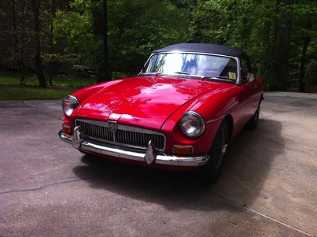
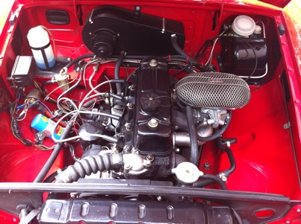
Weekend car that is drivable every day. Garage kept extra clean. Complete restoration done in 2003. Includes; rebuilt 1967 five bearing engine, four speed transmission with electronic overdrive, (approximately 20,000 miles on engine) electronic ignition, Weber carb, new leather British tan interior, new convertible top, new wire wheels and knock-offs, dog legs and floor boards replaced, black crinkled dash completely restored, body was sand blasted and painted roadster red and clear coated twice. Too many new parts to list. Asking $15,500. Thank you, Tom Costello

Editorial Staff has more pictures of this beautiful car if you are interested.
From Steve Donatone - Open the 2013 car show season and visit beautiful Colonial Williamsburg Virginia for the 14th Annual Williamsburg British Car Club British and European Car Show at Chickahominy Riverfront Park next to the intersection of the James and Chickahominy Rivers. Camping available thru James City County. Motorcycles welcome.
Registration form on our website.

Dear Fellow Club members,
Would you include in your events calendar and pass onto you members
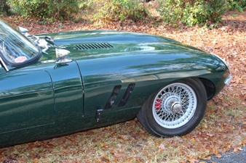
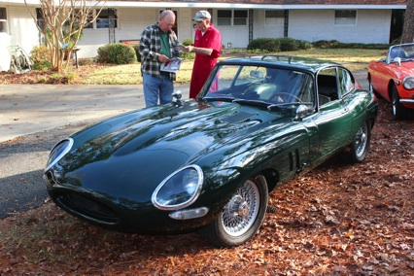
the following information about our 2013 annual British and European Car Show.
The Williamsburg British Car Club 14th Annual British and European Car Show
on April 13th, 2013(Sat) at Chickahominy Riverfront Park
1350 John Tyler Highway(Rt5) Williamsburg, VA 23185
web site - http://www.wmbgbrit.com/ registration form on website
contact – Roy Gavilan rgavilan@verizon.net or rgmgb65@hotmail.com
757-220-4774 Thanks, Roy Gavilan - Registration

Check out Craig Murden’s new cut outs on the Green Hornet - looks even better in person.

Not a bad shine for someone in their 50’s...
BMCCF Classified

BMCCF Regalia
Contact Trudy Williamson at: (910) 371-3222 for
ordering instructions.

Emb. S/S Denim Shirt $20.00
Emb. L/S Denim Shirt $23.00
Emb. White Golf Shirt $20.00
Emb. Hat, Union Jack $12.00
Emb. Hat, BMCCF Logo $12.00
Screen Print Ash Sweatshirt $20.00
BMCCF T shirt S/S $12.00
BMCCF T Shirt L?S $12.00
BMCCF Cloisonné Pin $ 5.00
BMCCF Grill Badge $35.00

BMCCF NAME TAGS
Official BMCCF name tags are required at all events or when
you are representing the club.
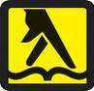
Originally ordered name tags are now available from Terry
Smith(910) 686-0785 $5.50 Pin Clasp $8.00 Magnet Clasp

AUTOWORKS, INC.
Foreign & Domestic Auto Specialists
We service all types of vehicles
From 1950’s to Present Day
Emissions Testing, Front end alignment
A/C repair
Carl Wilson (910) 791-5074
202 Antilles Ct. ( In Dutch Square industrial park )
Wilmington, NC 28405
Free Advice to BMCCF Members

RED WING SHOES
Independently Owned & Operated
3909-A Oleander Drive Wilmington , NC 28403-6714 MARK W. SHELTON

That’s All Folks
Charlie

Thank You
For your contributions to this newsletter

